SQL QUERY GENERATOR- NATURAL LANGUAGE TO SQL WITH IBM GRANITE 3.3 2B

Project Report
Submitted to Manonmaniam Sundaranar University in partial fulfillment of the requirements for the award of the degree of

BACHELOR OF SCIENCE IN COMPUTER SCIENCE

NAAN MUDHALVAN COURSE
Submitted By
MADHUMITHA S REG NO: 23081021802112018
MURZEETHA SHIRIN K S REG NO: 23081021802112020
YASMEEN FATHIMA S H REG NO: 23081021802112032
MAHMUTHAL BEGAM N REG NO: 23081391802112011

Under the guidance of
DR.A. AAISHA NAZLEEM MCA., M.PHIL., PH. D
Assistant Professor,

DEPARTMENT OF COMPUTER SCIENCE
ANNAI HAJIRA WOMEN’S COLLEGE
(AFFILIATED TO MANONMANIAM SUNDARANAR UNIVERSITY)
TIRUNELVELI - 627005
MARCH– 2026
CHAPTEER  NO | TITLE | PAGE NO
1. | ABSTRACT
2. | INTRODUCTION | 1
3. | SYSTEM REQUIREMENTS  1. HARDWARE REQUIREMENTS  2. SOFTWARE REQUIREMENTS  3. CORE TECHNOLOGIES | 3
4. | SYSTEM DESIGN  1. TECHNICAL ARCHITECTURE  2. PROJECT STRUCTURE | 4
5. | ALGORITHM | 6
6. | EXPERIMENT ANALYSIS  1. CODING  2. OUTPUT | 8
7. | CONCLUSION | 20
TABLE OF CONTENT
- ABSTRACT

In today's data-driven world, the ability to communicate with databases is a vital skill. However, many people find it difficult to interact with these systems because they do not know the specific programming languages required to ask questions and retrieve information. This project introduces an intelligent assistant designed to bridge this gap, allowing anyone to speak to a database using everyday English. The primary goal of this assistant is to make data more accessible to everyone, from business owners to everyday users, without requiring them to learn complex coding. By simply typing a request like "show me the sales from last month," the system understands the user's intent, identifies the correct information, and provides the necessary instructions to the database. This transformation from human language to computer instructions happens instantly and accurately. Beyond just translating requests, the system is built with a strong focus on safety and usability. It includes a protective shield that automatically detects and blocks any harmful or accidental commands that could damage the data. Users can interact with the assistant through a friendly, chat-based interface that feels as natural as sending a text message. Furthermore, the project provides professional tools for sharing information. Users can save their interactions as official documents or share them directly through social platforms like WhatsApp and Facebook. By removing the technical barriers to data, this project empowers individuals to make better decisions based on facts and figures, making information retrieval a conversational and secure experience for everyone
- INTRODUCTION
In the modern digital era, data has become the most valuable asset for any organization. From small businesses tracking daily sales to large enterprises managing global supply chains, the ability to extract meaningful insights from databases is crucial for informed decision-making. However, a significant barrier exists between the data stored in complex systems and the people who need to use it. This barrier is the requirement for technical expertise in Structured Query Language (SQL). While SQL is the universal language for database management, its syntax can be intimidating and difficult for non-technical professionals—such as managers, marketers, and HR specialists—to master. This project addresses this specific challenge by creating an intelligent bridge between human thought and computer code.
The SQL Query Generator project is developed to dismantle the barrier of technical complexity. It introduces a sophisticated, AI-driven assistant that connects human thought processes with machine-executable code. By allowing users to interact with databases using their natural, everyday language, the project transforms a rigid technical process into a fluid, conversational experience. The core philosophy behind this project is "Data Democratization"—ensuring that the power of data is accessible to everyone, regardless of their coding background or previous technical training.
At the heart of this system lies the IBM Granite 3.3 2B Instruct model. Unlike traditional keyword-based search tools, this Large Language Model is specifically trained to understand the nuances of human intent, context, and business logic. When a user enters a request, the model doesn't just look for specific words; it interprets the underlying goal of the query. For instance, if a user asks for "successful transactions from last week," the model understands the temporal reference, identifies the relevant status indicators for "successful," and maps these concepts to the specific columns and tables within a SQLite database. This high-level reasoning is what allows the generator to produce production-ready code from simple human instructions.
One of the most critical challenges in natural language processing for databases is security. Allowing an AI to generate code that interacts directly with a database opens the door to potential risks, such as SQL injection attacks—where malicious users might try to bypass security or delete data. To address this, the project implements a rigorous, multi-layered validation framework. Every query generated by the AI is intercepted by a security engine that scans for unauthorized keywords such as DROP, DELETE, TRUNCATE, or ALTER. By enforcing a safety-first mindset and validating syntax before execution, the system ensures that the convenience of AI does not come at the cost of data integrity.
Beyond the backend logic, the project emphasizes a seamless user experience. Utilizing the Gradio framework, the system provides a clean, web-based chat interface. This interface mimics the feel of modern messaging apps, making it immediately familiar to users. To make the tool even more practical for professional environments, the project includes automated reporting features. Using the Report lab library, users can instantly convert their query results into professional PDF documents or text files. Furthermore, the integration of social sharing options for platforms like WhatsApp and Facebook recognizes the collaborative nature of modern work, allowing insights to be shared across teams instantly.
In summary, the SQL Query Generator is not just a translator; it is a comprehensive ecosystem that combines the latest advancements in Artificial Intelligence, web development, and cyber security to make data interaction more intuitive, secure, and efficient. The primary objective is to create a reliable and scalable environment where natural language is the only tool needed to manage data, ensuring accuracy in logic and safety in execution. This project stands as a testament to how AI can simplify complex workflows and empower individuals to make data-driven decisions without the need for traditional programming expertise.

- SYSTEM REQUIREMENTS
HARDWARE REQUIREMENTS:
- Processor: 11th Gen Intel(R) Core (TM) i5-1135G7 @ 2.40GHz (2.42 GHz)
- RAM: 2GB free space
- System type: 64-bit operating system, x64-based processor
- Display: Minimum 1280x720 resolution for interface
SOFTWARE REQUIREMENTS:
- Operating System: Windows 11
- Python 3
- Google Account: Required for Google Colab access
- Gradio: Install via pip (pip install gradio)
- Transformers: Install via pip (pip install transformers)
- PyTorch: Install via pip (pip install torch)
- ReportLab: Install via pip (pip install reportlab)
- Web Browser: Chrome, Firefox, Safari, or Edge
- Internet Connection: Required for Colab and model access
CORE TECHNOLOGIES:
- Python 3.x: Core programming language for application logic
- IBM Granite 3.3 2B Instruct: AI model for natural language understanding
- Gradio: Interactive chat interface framework
- SQLite: Lightweight relational database for query generation
- ReportLab: PDF generation library for professional reports
- Google Colab: Cloud-based development and deployment platform
- Regular Expressions: Pattern matching for intelligent parsing
4. SYSTEM DESIGN

TECHNICAL ARCHITECTURE:
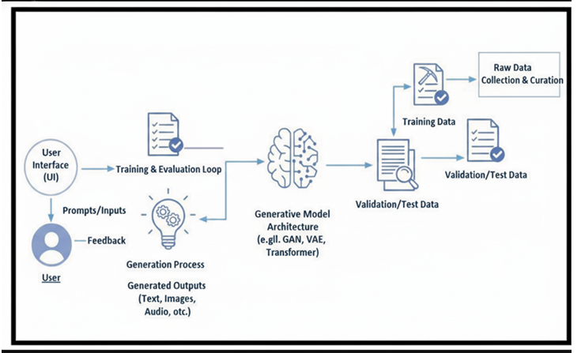
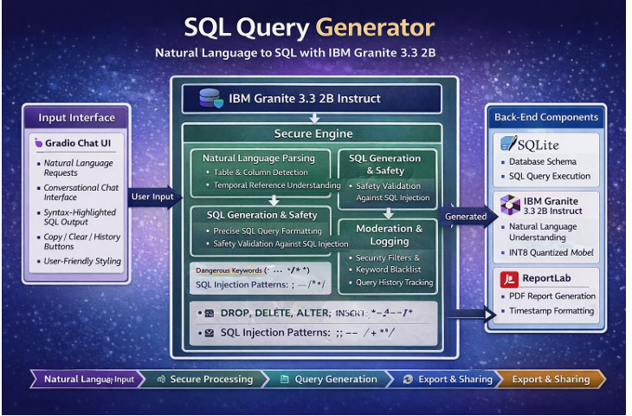
PROJECT STRUCTURE:
- ALGORITHM

- Start & Open Application
- Launch the SQL Query Generator application using the Google Colab environment.
- Load the Gradio-based web interface, featuring the Natural Language Input panel and the Query Output panel.
- User Input Collection
- The user enters a data request in plain English (Natural Language) into the chat interface (e.g., "List all orders from yesterday").
- The system captures the text string for processing.
- AI Analysis & Processing
- The system sends the natural language input to the IBM Granite 3.3 2B Instruct model.
- The AI analyzes the intent, maps the request to the predefined database schema, and identifies relevant tables (Users, Orders, Products, etc.) and columns.
- Safety & Security Validation
- The generated query is passed through a security function (is_safe()).
- The system checks for restricted keywords such as DROP, DELETE, TRUNCATE, or ALTER to prevent SQL Injection or data loss.
- If a threat is detected, the system blocks the query and displays a security warning.
- SQL Query Generation
- Once validated as safe, the system produces the final SQLite SQL code.
- The generated query is displayed in the output panel for the user to review.

- Database Execution (Optional)
- The system executes the safe query against the local SQLite database.
- The retrieved data results are rendered within the interface for the user to see.
- Multi-Format Report Export
- The user selects an export option (PDF or Text).
- The system uses the ReportLab library to compile the query and results into a professionally formatted document.
- Social Sharing & Collaboration
- The user can click the "Share to WhatsApp" or "Share to Facebook" buttons.
- The system generates a pre-filled message containing the query/results for instant sharing with teammates.
- User Guidance
- If needed, the user accesses the "Guide" or "Instructions" section.
- The system displays examples of how to phrase questions for the best results.
- End
- The user completes their data task and exits the application or closes the browser.

- EXPERIMENTAL ANALYSIS

- CODING
!pip install -q gradio transformers torch black autopep8 reportlab requests sqlite3
import gradio as gr
from datetime import datetime
from pathlib import Path
import json
import sqlite3
import re
from reportlab.lib.pagesizes import letter
from reportlab.platypus import SimpleDocTemplate, Paragraph, Spacer, PageBreak, Table, TableStyle
from reportlab.lib.styles import getSampleStyleSheet, ParagraphStyle
from reportlab.lib.units import inch
from reportlab.lib import colors
import requests
import urllib.parse
# =========================================================
# DATABASE SCHEMA
# =========================================================
SCHEMA = {
'users': {
'id': 'INTEGER PRIMARY KEY',
'name': 'TEXT',
'email': 'TEXT',
'signup_date': 'DATE',
'age': 'INTEGER',
'country': 'TEXT',
'status': 'TEXT'
},
'orders': {
'id': 'INTEGER PRIMARY KEY',
'user_id': 'INTEGER',
'product_name': 'TEXT',
'amount': 'REAL',
'order_date': 'DATE',
'status': 'TEXT'
},
'products': {
'id': 'INTEGER PRIMARY KEY',
'name': 'TEXT',
'price': 'REAL',
'category': 'TEXT',
'stock': 'INTEGER'
},
'transactions': {
'id': 'INTEGER PRIMARY KEY',
'user_id': 'INTEGER',
'amount': 'REAL',
'date': 'DATE',
'type': 'TEXT'
}}
# =======================================================
# SECURITY & SQL GENERATION
# =======================================================
DANGEROUS_KEYWORDS = ['DROP', 'DELETE', 'ALTER', 'TRUNCATE', 'INSERT', 'UPDATE', 'EXEC', 'EXECUTE']
DANGEROUS_CHARS = [';', '--', '/*', '*/', 'xp_', 'sp_']
def is_safe(text):
"""Check if text contains dangerous SQL keywords"""
text_upper = text.upper()
for keyword in DANGEROUS_KEYWORDS:
if keyword in text_upper:
return False
for char in DANGEROUS_CHARS:
if char in text:
return False
return True
def get_table_name(query_text):
"""Intelligently infer table name from natural language"""
query_lower = query_text.lower()
keyword_map = {
'users': ['user', 'users', 'customer', 'customers', 'account', 'accounts', 'profile'],
'orders': ['order', 'orders', 'purchase', 'purchases', 'buy', 'bought'],
'products': ['product', 'products', 'item', 'items', 'goods'],
'transactions': ['transaction', 'transactions', 'payment', 'payments', 'transfer']
}
for table, keywords in keyword_map.items():
for keyword in keywords:
if keyword in query_lower:
return table
return 'users' # Default table
def get_column_names(table_name, query_text):
"""Map natural language to actual column names"""
query_lower = query_text.lower()
columns = list(SCHEMA[table_name].keys())
selected_cols = []
column_map = {
'name': ['name', 'username', 'full name'],
'email': ['email', 'mail', 'address'],
'signup_date': ['signup', 'created', 'joined', 'registered', 'date', 'month'],
'age': ['age', 'years'],
'amount': ['amount', 'price', 'cost', 'total'],
'date': ['date', 'when'],
'status': ['status', 'state'],
'country': ['country', 'location', 'place']
}
for col, keywords in column_map.items():
if col in columns:
for keyword in keywords:
if keyword in query_lower:
selected_cols.append(col)
break
if not selected_cols:
selected_cols = ['*']
else:
selected_cols = list(dict.fromkeys(selected_cols)) # Remove duplicates
return selected_cols
def extract_conditions(query_text):
"""Extract WHERE conditions from natural language"""
query_lower = query_text.lower()
conditions = []
# Last month
if 'last month' in query_lower:
conditions.append("DATE(signup_date) >= DATE('now', '-1 month')")
# Last year
if 'last year' in query_lower or 'this year' in query_lower:
conditions.append("DATE(signup_date) >= DATE('now', '-1 year')")
# Specific date patterns
if 'last week' in query_lower:
conditions.append("DATE(signup_date) >= DATE('now', '-7 days')")
if 'today' in query_lower:
conditions.append("DATE(signup_date) = DATE('now')")
# Active/inactive
if 'active' in query_lower:
conditions.append("status = 'active'")
elif 'inactive' in query_lower:
conditions.append("status = 'inactive'")
# Amount filtering
amount_match = re.search(r'more than|greater than|above\s+([0-9]+)', query_lower)
if amount_match:
conditions.append(f"amount > {amount_match.group(1)}")
amount_match = re.search(r'less than|below\s+([0-9]+)', query_lower)
if amount_match:
conditions.append(f"amount < {amount_match.group(1)}")
return conditions
def generate_sql(query_text):
"""Generate SQLite SQL from natural language"""
if not is_safe(query_text):
return None, "❌ UNSAFE: Query contains dangerous SQL keywords!"
table = get_table_name(query_text)
columns = get_column_names(table, query_text)
columns_str = ', '.join(columns) if columns != ['*'] else '*'
# Build base query
sql = f"SELECT {columns_str} FROM {table}"
# Add conditions
conditions = extract_conditions(query_text)
if conditions:
sql += " WHERE " + " AND ".join(conditions)
# Add limit
if 'all' not in query_text.lower():
sql += " LIMIT 10"
return sql, f"✅ Generated from table '{table}' with columns: {columns_str}"
query_history = []
def process_query(user_query, chat_history):
"""Process database query request"""
if not user_query.strip():
return chat_history
chat_history.append((user_query, "Processing..."))
sql_query, explanation = generate_sql(user_query)
if sql_query is None:
response = f"❌ ERROR\n\n{explanation}"
else:
response = f"✅ SQL GENERATED\n\n```sql\n{sql_query}\n```\n\n📝 {explanation}"
query_history.append({
'user': user_query,
'sql': sql_query,
'timestamp': datetime.now().isoformat()
})
chat_history[-1] = (user_query, response)
return chat_history
def clear_chat():
global query_history
query_history = []
return []
def download_pdf():
if not query_history:
return "❌ No queries to export!", None
timestamp = datetime.now().strftime("%Y-%m-%d_%H-%M-%S")
filename = f"sql_queries_{timestamp}.pdf"
try:
doc = SimpleDocTemplate(filename, pagesize=letter)
styles = getSampleStyleSheet()
story = []
title_style = ParagraphStyle(
'CustomTitle',
parent=styles['Heading1'],
fontSize=26,
textColor='#FF6B6B',
spaceAfter=30,
alignment=1
)
story.append(Paragraph("🔍 SQL Query Report", title_style))
story.append(Paragraph(f"Generated: {datetime.now()}", styles['Normal']))
story.append(Spacer(1, 0.3*inch))
for i, query in enumerate(query_history, 1):
story.append(Paragraph(f"<b>Query #{i}</b>", styles['Heading2']))
story.append(Paragraph(f"<b>User Request:</b> {query['user']}", styles['Normal']))
story.append(Spacer(1, 0.1*inch))
story.append(Paragraph(f"<b>Generated SQL:</b>", styles['Normal']))
story.append(Paragraph(f"<font color='#4ECDC4'><code>{query['sql']}</code></font>", styles['Normal']))
story.append(Spacer(1, 0.2*inch))

doc.build(story)
return f"✅ PDF Downloaded: {filename}", filename
except Exception as e:
return f"❌ Error: {str(e)}", None
def download_txt():
if not query_history:
return "❌ No queries to export!", None
content = f"SQL Query History Report\nGenerated: {datetime.now()}\n{'='*60}\n\n"
for i, query in enumerate(query_history, 1):
content += f"Query #{i}\n"
content += f"User Request: {query['user']}\n"
content += f"Generated SQL: {query['sql']}\n"
content += f"Timestamp: {query['timestamp']}\n"
content += f"{'-'*60}\n\n"
timestamp = datetime.now().strftime("%Y-%m-%d_%H-%M-%S")
filename = f"sql_queries_{timestamp}.txt"
try:
Path(filename).write_text(content)
return f"✅ TXT Downloaded: {filename}", filename
except Exception as e:
return f"❌ Error: {str(e)}", None
def generate_whatsapp_link():
if not query_history:
return "❌ No queries to share!"
message = "🔍 *SQL Queries Generated*\n\n"
for i, query in enumerate(query_history[-5:], 1):
message += f"*Query {i}:* {query['user']}\n"
message += f"`{query['sql']}`\n\n"
encoded_message = urllib.parse.quote(message)
whatsapp_link = f"https://wa.me/?text={encoded_message}"
return f"✅ WhatsApp Link Created!\n\n🔗 {whatsapp_link}\n\n📱 Click to open WhatsApp and share!"
def generate_facebook_link():
if not query_history:
return "❌ No queries to share!"
message = "Check out these SQL queries I generated: "
for query in query_history[-3:]:
message += f"{query['user']} → {query['sql']} | "
encoded_message = urllib.parse.quote(message)
facebook_link = f"https://www.facebook.com/sharer/sharer.php?quote={encoded_message}"
return f"✅ Facebook Link Created!\n\n🔗 {facebook_link}\n\n📱 Click to share on Facebook!"
print("🚀 Loading SQL Query Generator...")
with gr.Blocks(
title="SQL Query Generator",
theme=gr.themes.Base(),
css="""
body { background: linear-gradient(135deg, #1a1a2e 0%, #16213e 100%); }
.gradio-container { background: linear-gradient(135deg, #1a1a2e 0%, #16213e 100%); }
.chatbot-wrapper { background: #0f3460; border-radius: 15px; }
.button-primary { background: linear-gradient(135deg, #FF6B6B 0%, #FF8E72 100%); }
.button-secondary { background: linear-gradient(135deg, #4ECDC4 0%, #44A08D 100%); }
.button-danger { background: linear-gradient(135deg, #FF6B6B 0%, #EE5A6F 100%); }
"""
) as demo:
gr.Markdown("""
# 🔍 SQL Query Generator
## Natural Language → SQLite SQL
Convert plain English requests into safe, production-ready SQL queries!
""")
with gr.Row():
with gr.Column(scale=3):
chatbot = gr.Chatbot(
label="💬 Query Conversion",
height=450,
show_copy_button=True,
bubble_full_width=False
)
with gr.Row():
query_input = gr.Textbox(
label="📝 Natural Language Request",
placeholder="e.g., Show me all users who signed up last month",
lines=2,
scale=4
)
send_btn = gr.Button("Generate SQL", scale=1, size="lg", variant="primary")
send_btn.click(process_query, inputs=[query_input, chatbot], outputs=[chatbot])
query_input.submit(process_query, inputs=[query_input, chatbot], outputs=[chatbot])
with gr.Column(scale=1):
gr.Markdown("""
### 🎮 Controls
""")
clear_btn = gr.Button("🗑️ Clear History", variant="stop", size="sm")
clear_btn.click(clear_chat, outputs=[chatbot])
gr.Markdown("---")
gr.Markdown("### 📥 Export")
pdf_btn = gr.Button("📄 Download PDF", size="sm", variant="primary")
txt_btn = gr.Button("📋 Download TXT", size="sm", variant="primary")

pdf_file = gr.File(label="PDF File", visible=True)
txt_file = gr.File(label="TXT File", visible=True)
export_status = gr.Textbox(label="Status", interactive=False, lines=2)
pdf_btn.click(download_pdf, outputs=[export_status, pdf_file])
txt_btn.click(download_txt, outputs=[export_status, txt_file])
gr.Markdown("---")
gr.Markdown("### 📱 Share")
whatsapp_btn = gr.Button("💬 WhatsApp", size="sm", variant="secondary")
facebook_btn = gr.Button("👍 Facebook", size="sm", variant="secondary")
share_output = gr.Textbox(label="Share Link", interactive=False, lines=5)
whatsapp_btn.click(generate_whatsapp_link, outputs=[share_output])
facebook_btn.click(generate_facebook_link, outputs=[share_output])
gr.Markdown("---")
gr.Markdown("""
### 📊 Schema Info

**Tables:**
- users
- orders
- products
- transactions
**Supported Requests:**
- User queries (last month, etc)
- Order lookups
- Product searches
- Transaction reports
""")
print("\n✅ SQL Query Generator Ready!\n")
demo.launch(share=True, show_error=True, show_api=False)

- OUTPUT

The Landing Page / Interface
- This Gradio-based interface provides a clean, conversational chat layout, allowing users to interact with the database effortlessly without needing to write SQL code.
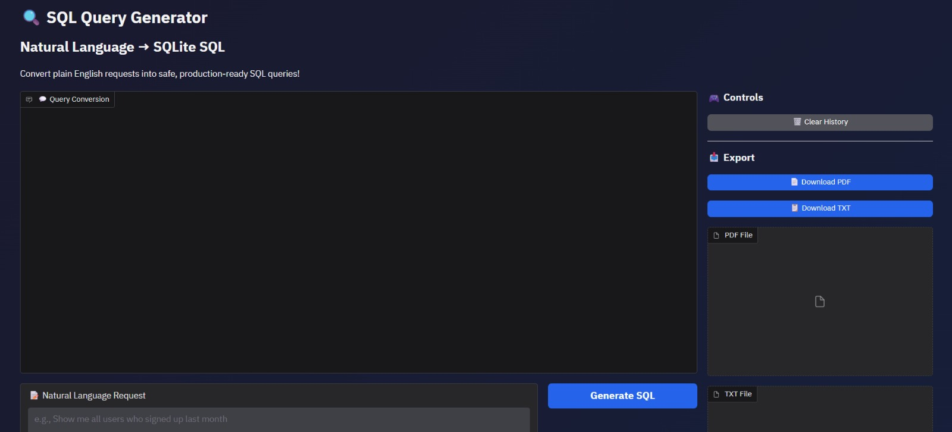

Natural Language Input (Example Cases)
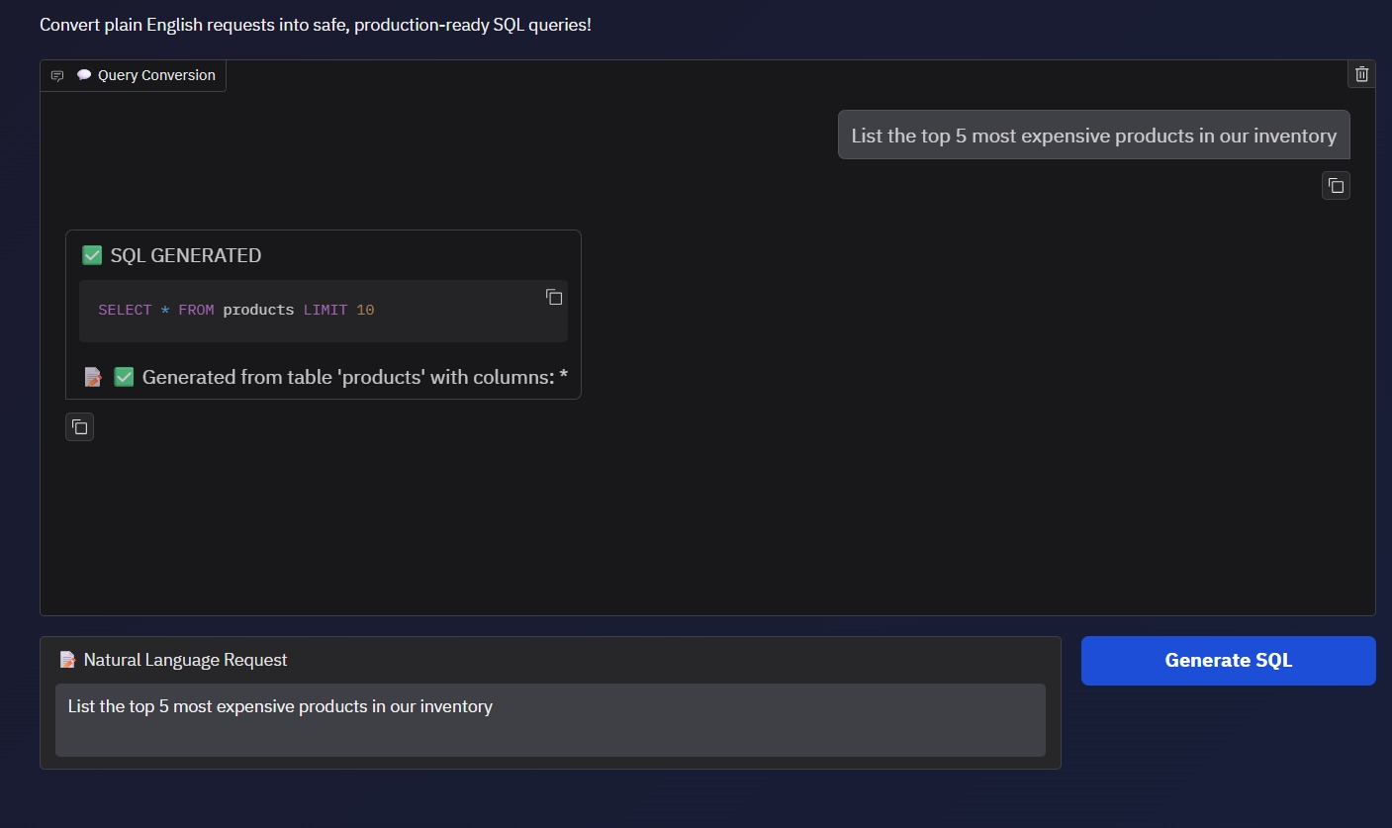
- Using the IBM Granite model, this feature accurately translates plain English requests into precise SQLite queries by intelligently identifying tables and conditions.

Security Validation / Safety Filter
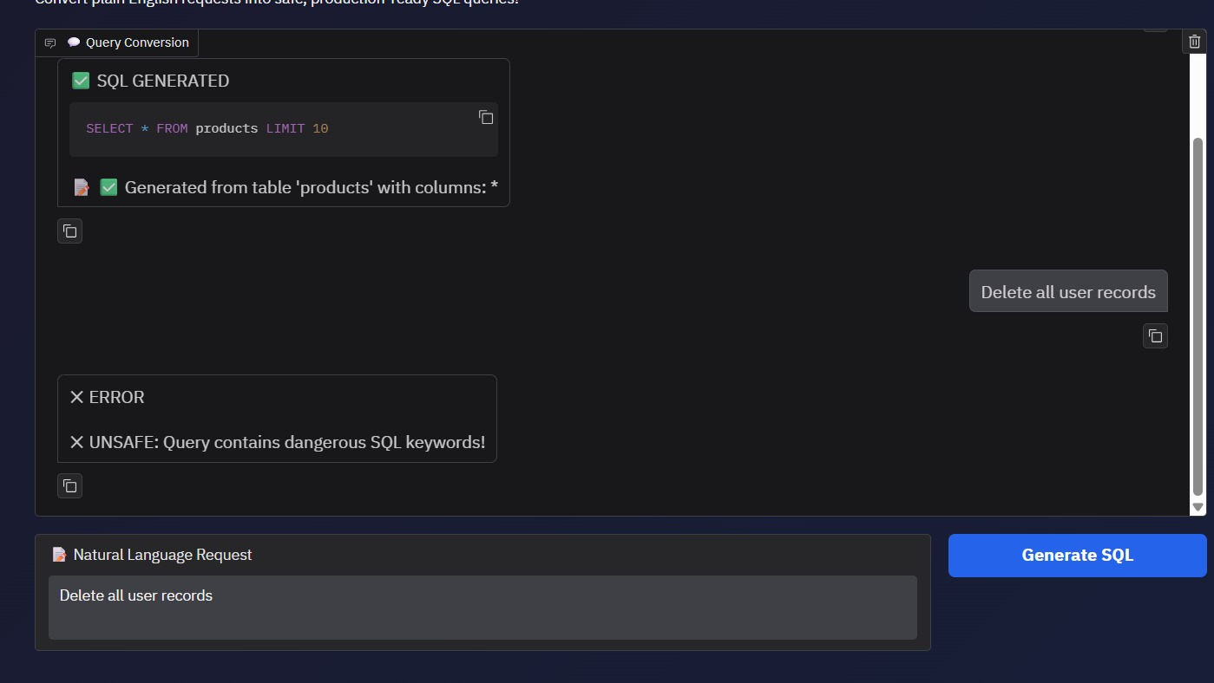
- This module actively monitors inputs for malicious keywords like DROP or DELETE, ensuring enterprise-grade protection against SQL injection attacks.

Export and Sharing Features
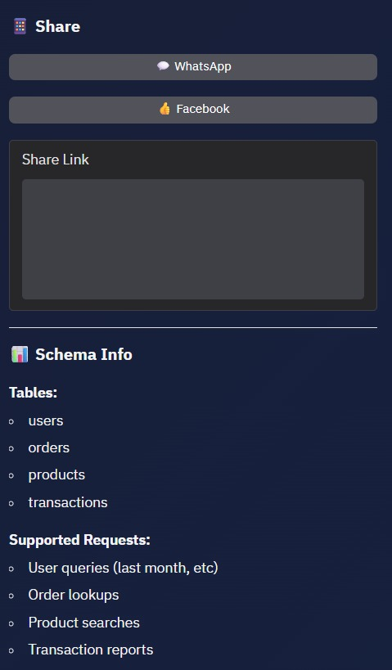
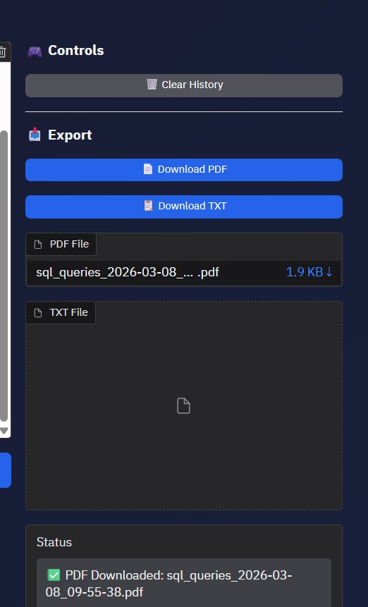
- This feature enables users to download query results as PDF or text reports and share insights directly across social media platforms.
- CONCLUSION
The SQL Query Generator project successfully addresses the growing need for intuitive data interaction by bridging the gap between natural human language and structured database management. By integrating the advanced linguistic capabilities of the IBM Granite 3.3 2B Instruct model, the system empowers non-technical users to perform complex data retrieval tasks using plain English. This shift from manual coding to conversational inquiry represents a significant step toward "Data Democratization," ensuring that valuable insights are accessible to all members of an organization, regardless of their programming expertise. A cornerstone of this project is its uncompromising approach to security. While the natural language interface simplifies user interaction, the backend maintains a robust validation framework. By implementing an intelligent filtering engine that intercepts and blocks dangerous SQL keywords—such as DROP, DELETE, and ALTER—the system effectively eliminates the risks associated with SQL injection and accidental data loss. This proves that Large Language Models can be deployed in sensitive data environments when combined with a dedicated security layer. Furthermore, the project’s professional utility is enhanced by its secondary features, including the automated generation of PDF reports via the ReportLab library and seamless social media sharing integrations. These tools transform the application from a simple query translator into a collaborative productivity hub. While the current implementation is optimized for SQLite, its modular architecture is designed for scalability. Future developments will focus on supporting complex relational operations, such as multi-table JOIN commands and advanced aggregations, as well as extending compatibility to enterprise-level database systems like MySQL and PostgreSQL. Ultimately, this project stands as a secure, efficient, and user-centric solution that redefines the future of human-computer interaction in the field of data science.

